ARDUINO BLUETOOTH ROBOT

1. Introduction of the project:

This is the first project I have ever made, it’s an Arduino Bluetooth robot, all the structure can be made in a 3D printer.

I design all the structure, you can download the files if you want to replicate the robot.

It’s an 2WD robot with a “crazy ball”, it can go in 8 directions. You have a buzzer too, if you want to make some noise.

You can see all the materials you need in the B.O.M of the project.

1. Electric scheme:

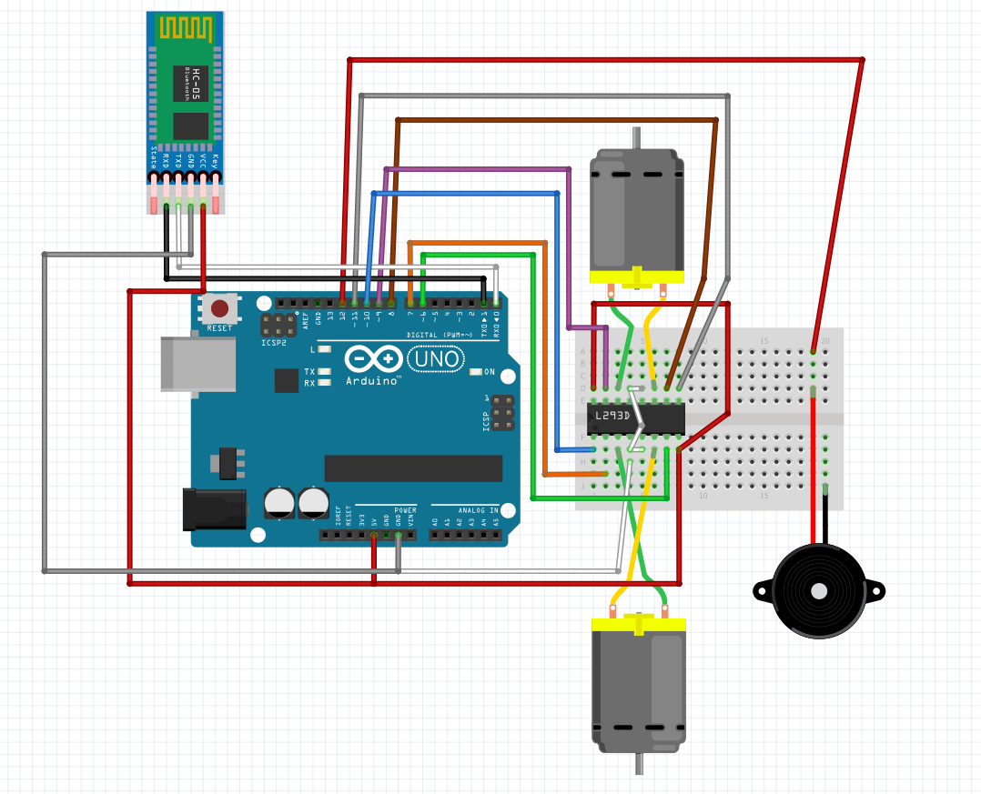

1. Assembly description:

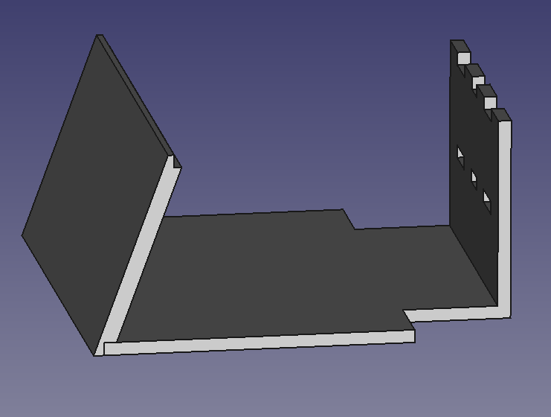1-First of all you have to paste the “Base and back” with the “Front side” using super glue.

you will have something like that

2-Then you have to add the “Tire wheel” on the “Pololu wheel”, and all of that, put in the “Pololu motor”.

Use the “Motor bracket” with “screw 3x5” to link the motor with the base, previously you have to made the 4 hole.

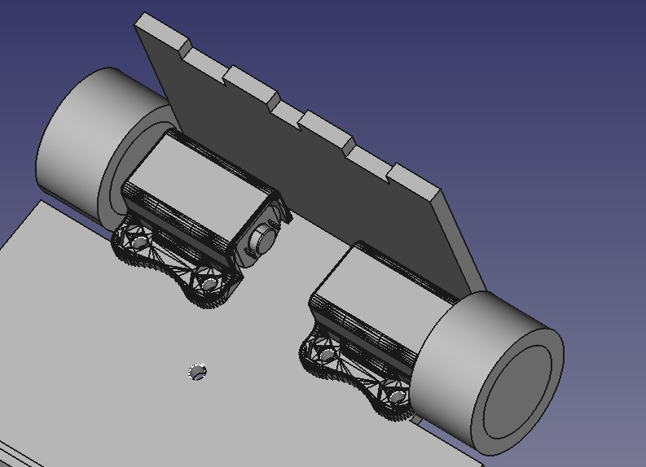

3-Now you have to make the “crazy ball”, its made with the “ball caster” + “metal ball”+ “clamp”.

Use the “screw 3x15” to add this piece with the base

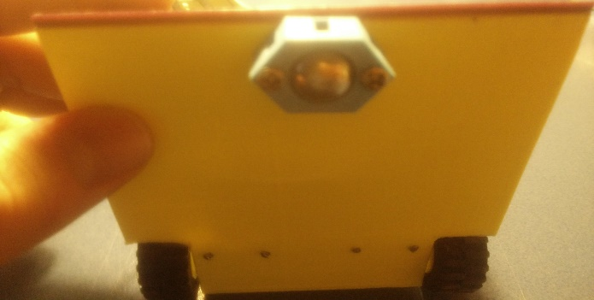

4-The next step is making all the cabling, use the electric scheme and make the same connections.

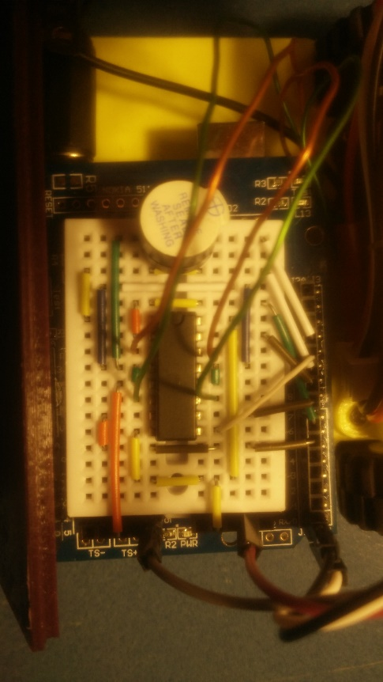

Use the “adhesive Velcro” to link the Arduino to the base.

5- The last step is making the dc supply

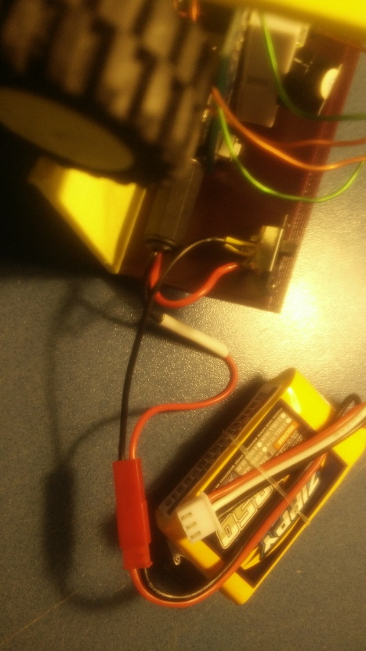

6- assemble everything and this is the result

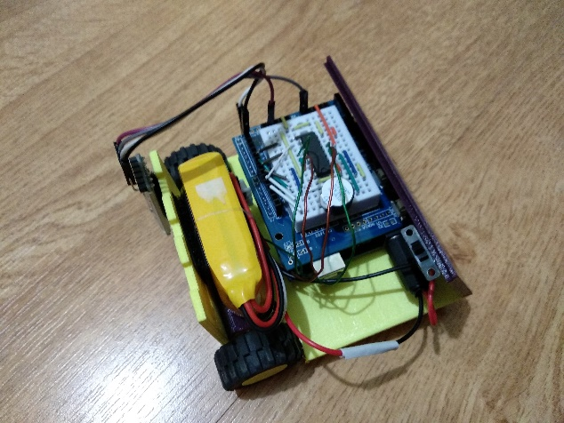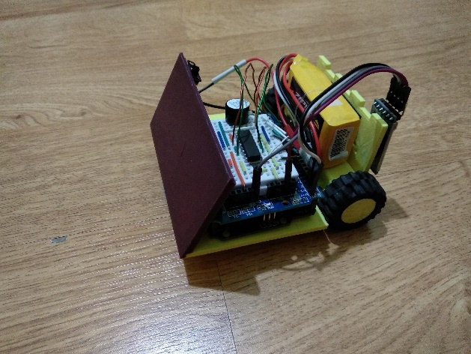

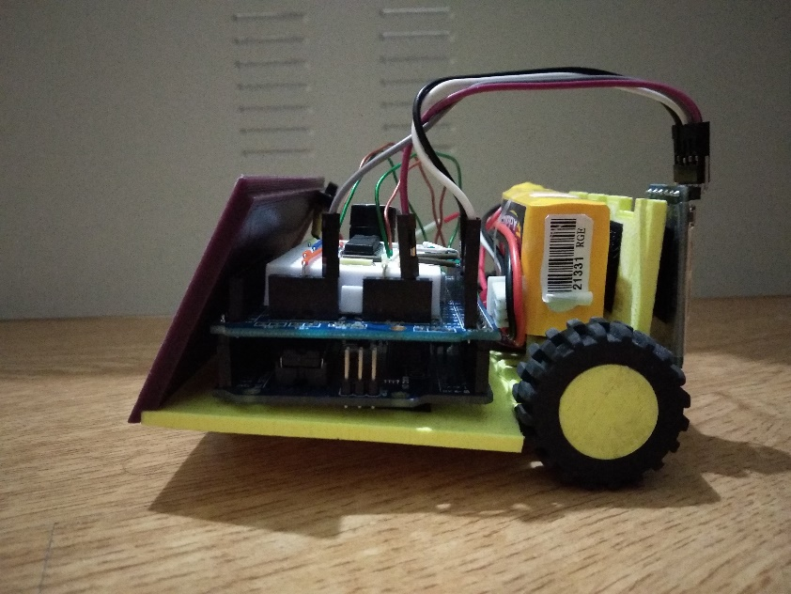

4. Arduino program

/\*PROGRAMA PARA CONTROLAR EL ROBOT MEDIANTE BLUETOOTH

\* USANDO FUNCIONES DE USUARIO

\*/

char dato;

int vd;

int vi;

int a;

int b;

void setup( ) {

//configuramos E/S digitales del robot

Serial.begin(9600);

pinMode(8,OUTPUT); // Motor derecha

pinMode(9,OUTPUT); //

pinMode(6,OUTPUT); // Motor izquierda

pinMode(7,OUTPUT); //

pinMode(12,OUTPUT); // buzzer

}

void loop( ) {

if (Serial.available() > 0) {

dato = Serial.read();

Serial.println(dato);

switch (dato) {

case ('F'): {

//robot movimiento adelante

movimiento(1,0,255,255);

break;

}

case ('B'): {

//robot movimiento atrás

movimiento (0,1,255,255);

break;

}

case ('L'): {

//robot movimiento izquierda

movimiento (1,0,0,255);

break;

}

case ('R'): {

//robot movimiento derecha

movimiento(1,0,255,0);

break;

}

case ('G'): {

//robot movimiento adelante y izquierda

movimiento (1,0,85,255);

break;

}

case ('I'): {

//robot movimiento adelante y derecha

movimiento(1,0,255,85);

break;

}

case ('H'): {

//robot movimiento atras y izquierda

movimiento (0,1,85,255);

break;

}

case ('J'): {

//robot movimiento atras y derecha

movimiento(0,1,255,85);

break;

}

case ('S'): {

//paro motores

analogWrite (11,0);

analogWrite (10,0);

break;

}

case ('V'): {

//pito

digitalWrite(12,1);

delay(50);

digitalWrite(12,0);

break;

}

case ('v'): {

//pito

digitalWrite(12,1);

delay(50);

digitalWrite(12,0);

break;

}

case ('X'): {

//giro

analogWrite (11,255);

digitalWrite (8,1);

digitalWrite (9,0);

analogWrite (10,255);

digitalWrite (6,1);

digitalWrite (7,0);

delay(2000);

break;

}

case ('x'): {

//giro

analogWrite (11,255);

digitalWrite (8,0);

digitalWrite (9,1);

analogWrite (10,255);

digitalWrite (6,0);

digitalWrite (7,1);

delay(2000);

break;

}

}

}

}

void movimiento (int a,int b,int vd,int vi){

analogWrite (11,vd);

digitalWrite (8,a);

digitalWrite (9,b);

analogWrite (10,vi);

digitalWrite (6,b);

digitalWrite (7,a);

}